Comparative Evaluation of Machine Learning Models for Phishing Website Detection Using URL-Based Features
Enoch Success Boakai, Sunil Lalchand Bajeja are with the Faculty of Computer Applications, Marwadi University, Rajkot, Gujarat, India
Mohammad Shabaz is with the Marwadi University Research Center, Department of Computer Engineering, Faculty of Engineering and Technology, Marwadi University, Rajkot, 360003, Gujarat, India (e-mail: enoch.boakai130233@marwadiuniversity.ac.in; sunil.bajeja@marwadieducation.edu.in; bhatsab4@gmail.com)

Enoch Success Boakai¹, Sunil Lalchand Bajeja², Mohammad Shabaz³

This work is self-funded. We did not receive any external funding in any form.

Digital Object Identifier:
10.1109/MCOMSTD.XXXX.XXXXXX
Date of Current Version:
XX XXXX XXXX
Date of Publication:
XX XXXX XXXX

Abstract
Phishing remains one of the most pervasive cybersecurity threats, exploiting human trust and deceptive website design to steal sensitive credentials. Traditional defense mechanisms, such as blacklists and heuristic rules, often fail to detect zero-day and evolving phishing attacks. This study presents a comparative analysis of machine learning algorithms for phishing detection based on URL-level features using the UCI Phishing Websites Dataset, which contains 11,055 instances and 30 predictive attributes. Five classifiers, Logistic Regression, Decision Tree, Random Forest, Support Vector Machine (SVM), and K-Nearest Neighbors (KNN) were implemented and rigorously evaluated on statistical measures. Experimental results indicate that Random Forest and SVM achieves superior performance and if tuned further, it enhances the predictive capability too. These findings not only highlight the effectiveness of ensemble methods and kernel-based classifiers in phishing detection but also provide valuable insights into the discriminative power of specific URL-based features. The outcomes of this work contribute to the design of robust, interpretable, and data-driven approaches for proactive phishing mitigation.

I. Introduction
Phishing is a form of social-engineering attack in which an adversary attempts to deceive users into divulging sensitive information such as credentials, financial details, or personal data, or into performing actions that compromise security, for example, installing malware or transferring funds. Phishing attacks exploit human trust and the openness of web and email protocols to harvest credentials, commit fraud, and perpetrate account takeover [1]. A typical phishing attack process flow is shown in Figure 1. Phishing remains one of the most widespread and damaging cyber threats because it combines technical exploitation with psychological manipulation, making purely technical defenses insufficient on their own.

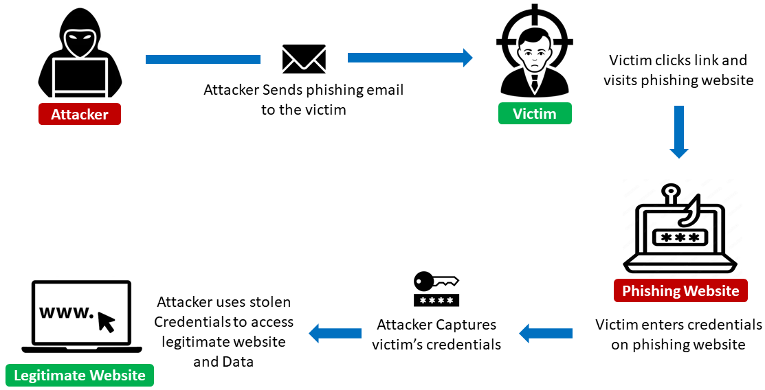

Figure 1: Phishing Attack Process Flow
Spear phishing refers to highly targeted phishing messages directed at specific individuals or groups, where the attacker uses contextual information (reconnaissance) to increase believability [1] Spear phishing is often used in initial compromise and business-email-compromise (BEC) attacks and typically yields higher success rates than generic phishing due to personalization. A related subtype is whaling, which targets high-value executives or decision makers (the “big fish”) to enable high-impact fraud, such as fraudulent wire transfers [2]. Clone phishing and deceptive webpages represent another class of attacks in which adversaries create near-identical copies of legitimate emails or web pages (clone phishing) or host look-alike web pages designed to harvest credentials, with visual mimicry being common [3]. Beyond email, phishing is also delivered through mobile and telephony channels. Smishing refers to phishing delivered via SMS, while vishing exploits voice calls. Both attack types capitalize on the user’s trust in telephony or messaging channels, and they are increasingly used because mobile users are often less suspicious or less able to inspect message details. Another prominent technique is pharming, in which attackers redirect users to malicious hosts either by compromising DNS infrastructure, poisoning caches, or abusing domain registration and hosting services such as fast-flux networks [4].
Finally, watering-hole attacks and compromised hosts involve attackers injecting phishing or credential-harvesting content into legitimate websites often frequented by targeted users. This increases reach while exploiting the reputation of trusted hosts. These variants are not mutually exclusive; indeed, sophisticated campaigns often chain multiple techniques, for example, spear phishing leading to a watering-hole redirect to maximize their probability of success.
URL-based detection focuses on features extractable from the URL string, lexical tokens, length, special characters, subdomain count, IP-address usage, HTTPS adoption, and top-level-domain characteristics, plus host-level metadata such as domain age, registrar. These fast-to-compute, low-privilege features scale in proxies, email gateways, and client agents for immediate triage; although they cannot capture visual mimicry or page content, they remain effective first-line, inexpensive filters. Given the diversity of phishing tactics and defenders' operational constraints, systematically evaluating classical and ensemble machine-learning methods on URL-based features helps identify lightweight models that balance detection, latency, and interpretability. This paper compares logistic regression, SVM, KNN, decision trees, and Random Forest (baseline and tuned) on a public phishing-URL dataset using a stratified hold-out protocol, reporting accuracy, precision, recall, F1, and ROC-AUC; results guide deployment choices between inline filtering and offline forensic analysis, along with recommended practices.
II. Related Work

Traditional methods of phishing detection, such as blacklists and heuristic rules, have limitations in accurately identifying new and evolving phishing techniques. Machine learning (ML) approaches have emerged as promising solutions for phishing detection, leveraging URL-based features to classify websites as legitimate or malicious.
Several studies have explored the application of ML algorithms to detect phishing websites based on URL features. A comprehensive evaluation of seven classification algorithms for phishing website detection was conducted, employing precision, recall, and F1-score metrics to assess performance [5]. The findings highlighted the effectiveness of ML techniques in identifying phishing websites. However, the study focused primarily on accuracy metrics and did not evaluate robustness across different feature sets or real-world imbalanced datasets, which limits generalizability. Similarly, the effectiveness of machine learning, particularly XGBoost, for high accuracy phishing URL detection using comprehensive feature sets was demonstrated [6], using a dataset of labeled phishing and legitimate URLs, characterized by 30 distinct features encompassing lexical, host-based, and content-related attributes. Performance analysis revealed that the XGBoost classifier achieved the highest accuracy, correctly classifying approximately 97.4% of URLs in the test set. A limitation of this work is that it did not compare multiple classical algorithms in depth, and feature selection impact was not fully explored.
Comparative studies have been instrumental in evaluating the performance of various ML algorithms in phishing detection. Seven machine learning models, namely Logistic Regression (LR), k-Nearest Neighbors (KNN), Support Vector Machine (SVM), Naive Bayes (NB), Decision Tree (DT), Random Forest (RF), and Gradient Boosting were evaluated to assess their efficiency in detecting phishing domain. Using the UCI phishing domains dataset as a benchmark, the study found that Gradient Boosting and Random Forest models exhibited superior performance compared to other techniques. Nevertheless, the study did not explore hyperparameter tuning systematically, which may have limited model optimization and final performance.
Phishing causes direct financial loss, data breaches, account takeover, and down-stream fraud. Industry and incident reports consistently rank phishing among the top causes of security incidents and breaches. Longitudinal analyses and annual breach reports highlight phishing’s central role in credential compromise and as an entry point for larger intrusions. From an operational perspective, phishing remains especially challenging because attackers can rapidly create and retire domains, craft new obfuscation techniques such as URL shorteners, multi-stage redirects, and Unicode homoglyphs, and adapt content to evade static signature-based defenses and blacklists. The combination of rapid adversary iteration and the human susceptibility element makes defense a continuous arms race requiring adaptive, multi-layered countermeasures.
Several factors make phishing detection difficult in practice. Adversarial adaptation is a key challenge, as attackers quickly change domains, path structures, and content to evade signature-based or reputation systems. Automated domain generation and large-scale hosting services further enable rapid campaign turnover. Another constraint is information availability: lightweight, inline defenses such as URL inspections in proxies or email gateways can only access lexical URL features before page fetch, while richer signals such as rendered content, visual screenshots, or WHOIS/registry data may be delayed or unavailable. This trade-off between latency and richness complicates real-time detection design [7]. Data quality and concept drift also present major challenges, as datasets used to train detectors often suffer from labelling noise, sampling bias, or temporal leakage. Because phishing patterns evolve continuously, models trained on historical data may degrade without regular retraining or adaptation, necessitating time-aware splits and streaming-based evaluation protocols to avoid optimistic performance estimates. Furthermore, phishing datasets are inherently imbalanced, and the operational cost of false negatives (missed phishing) typically outweighs that of false positives. This imbalance demands specialized evaluation metrics and thresholding strategies to reflect the cost-sensitive nature of phishing detection [8].

III. Methodology

The experimental setup and machine learning algorithms were carefully chosen and configured to ensure consistent and reproducible results. Python programming language was used for implementation as well as several scientific libraries, including Pandas and NumPy for data loading, cleaning, manipulation, and numerical computation; Scikit-learn for machine learning modeling, preprocessing, and evaluation; and Matplotlib together with Seaborn for visualizing feature distributions and performance metrics.
For the comparative analysis, five supervised machine learning classifiers were selected: Logistic Regression (LR), Decision Tree (DT), Random Forest (RF), Support Vector Machine (SVM), and K-Nearest Neighbors (KNN). These algorithms were chosen due to their wide application and demonstrated effectiveness in classification tasks, particularly in cybersecurity and phishing detection research. Each model was trained on the training subset and subsequently evaluated on the testing subset. Standardization using StandardScaler was applied where appropriate, specifically for LR, SVM, and KNN.
The Receiver Operating Characteristic (ROC) curve is a widely used graphical method for visualizing the performance of binary classification models across varying threshold values [9]. It depicts the True Positive Rate (TPR), or recall, against the False Positive Rate (FPR). TPR reflects the proportion of correctly identified positive cases, while FPR indicates the proportion of negatives misclassified as positives. Ideally, a perfect model produces a curve that passes through the upper-left corner (TPR = 1, FPR = 0), representing flawless sensitivity and specificity. Conversely, a random classifier generates a diagonal line from the lower-left to the upper-right corner.
The Area Under the Curve (AUC-ROC) serves as a single quantitative measure of model performance, where higher values indicate stronger discriminative ability. This evaluation approach provides a nuanced view of model strengths and limitations, guiding researchers in determining suitability for real-world deployment. Based on these insights, models demonstrating superior performance were subjected to hyperparameter tuning and feature selection to further optimize predictive accuracy and enhance robustness in phishing detection tasks.

3.1 Machine Learning Algorithms: Theory and Formulation

This study employs five distinct supervised learning algorithms, selected for their methodological diversity and proven performance in binary classification tasks. The following subsections detail the fundamental logic, mathematical formulation and algorithmic steps for all models applied in this work, with key hyperparameters discussed for the tuned models, to establish a solid theoretical base for the empirical evaluation.

Logistic Regression (LR)
Logistic Regression is a linear model for classification [10]. It models the probability that a given instance (a feature vector of a URL) belongs to the positive class (phishing) by applying the logistic sigmoid function to a linear combination of input features.
The model computes a weighted sum of input features plus a bias term, which is then passed through the sigmoid function to produce a probability between 0 and 1. The weights and bias are learned by minimizing the log-loss (cross-entropy) cost function over the training data, typically using iterative optimization algorithms such as Gradient Descent or its variants. For a new URL feature vector, the model calculates the probability of belonging to the phishing class. If this probability is greater than or equal to 0.5, the URL is classified as phishing; otherwise, it is classified as legitimate.

Decision Tree (DT)
A Decision Tree learns a hierarchy of simple decision rules inferred from the data features[11]. It recursively partitions the feature space into regions, aiming to maximize the purity of the resulting subsets with respect to the class label.
The tree is built top-down from a root node. At each node, the best split is chosen by maximizing Information Gain, which measures the reduction in impurity between the parent node and its child nodes. Common impurity measures include Gini Impurity and entropy.
For a new instance, the tree is traversed from the root to a leaf by following the decision rules at each internal node. The predicted class is then assigned based on the majority class of the leaf node reached.

Random Forest (RF)
Random Forest is an ensemble method that operates by constructing a multitude of Decision Trees during training and outputs the majority vote of their predictions for classification [12]. It introduces randomness through bagging (bootstrap aggregating) and random feature selection, which helps create diverse trees, reduce variance, and mitigate overfitting.
Each tree is trained on a bootstrap sample drawn with replacement from the original training set. When splitting a node, the algorithm considers only a random subset of features, further decorrelating the trees. For a new instance, every tree produces a class prediction, and the final result is determined by majority voting across all trees.
The main hyperparameters influencing performance include the number of trees, maximum depth, minimum samples required to split a node, and minimum samples required at a leaf node. These parameters were tuned to optimize classification accuracy.

Support Vector Machine (SVM)
The goal of the Support Vector Machine is to find the optimal hyperplane that separates the data points of different classes with the maximum possible margin[12]. For non-linearly separable data, it utilizes the kernel trick to map inputs into a high-dimensional feature space where a linear separation is possible.
In practice, SVM introduces slack variables to allow soft margins and uses a regularization parameter (C) to balance margin maximization against classification error. The dual formulation of the optimization problem enables efficient use of kernel functions, such as the Radial Basis Function (RBF), to handle complex non-linear boundaries.
For a new instance, the predicted class is determined using a decision function based on the support vectors and kernel evaluations.
The critical hyperparameters include C (regularization strength), γ (kernel coefficient for RBF), and the kernel type. Proper tuning of these parameters improves the trade-off between margin maximization and classification accuracy.

K-Nearest Neighbors (KNN)
K-Nearest Neighbors is a non-parametric, instance-based learning algorithm [13]. It predicts the class of a new instance by taking a majority vote of the classes of its k most similar instances in the training set. The algorithm relies entirely on the stored data and a chosen distance metric.
For a new instance, the algorithm calculates the distance to all training instances, identifies the k nearest neighbors, and assigns the predicted class as the majority label among those neighbors.

In summary, Logistic Regression models probability via a sigmoid curve; Decision Tree splits data hierarchically based on feature values; Random Forest ensembles multiple trees with majority voting; Support Vector Machine separates classes using an optimal hyper-plane; and K-Nearest Neighbors predicts outcomes based on the majority class of the nearest data points.

3.2 Evaluation Metrics
Evaluation metrics provide a fundamental means for assessing classification models, offering a detailed summary of prediction outcomes. In phishing website detection, analyzing prediction results is particularly important because false negatives (missed phishing sites) and false positives (legitimate sites incorrectly flagged) have asymmetric consequences. All subsequent evaluation metrics, accuracy, precision, recall, and F1-score, quantify different aspects of model performance.
Accuracy is defined as the proportion of correctly classified instances relative to the total number of cases in the dataset. Precision measures the proportion of correctly predicted positive cases out of all predicted positives. Recall quantifies the proportion of true positives identified out of all actual positives. F1-score is the harmonic mean of precision and recall, providing a balanced measure of performance. Collectively, these metrics offer a comprehensive assessment of model effectiveness, capturing both correct classification and error patterns.

To further enhance detection performance, hyperparameter tuning was performed for Random Forest and SVM using GridSearchCV. This rigorous and reproducible approach ensured a fair and systematic comparison of machine learning algorithms for phishing detection.

3.3 Dataset Description and Preprocessing

This study utilized the UCI Phishing Websites Dataset [14]. Originally provided in ARFF format, it was converted to CSV for ease of processing. This dataset is publicly available and serves as a comprehensive resource for researchers and practitioners in cybersecurity. It is widely used in phishing detection research and is specifically designed to capture structural, content-based, and traffic-related characteristics of phishing and legitimate websites. The dataset comprises 11,055 instances and 32 attributes, where each instance represents a website characterized by multiple URL-based features such as the presence of an IP address, length of the URL, use of special characters, and SSL certificate information. The final attribute, Result, serves as the class label, with values of 1 indicating phishing websites and –1 representing legitimate websites. An initial analysis showed that the dataset is relatively balanced, containing 6,157 phishing websites (55.7%) and 4,898 legitimate websites (44.3%), thereby ensuring fair representation of both classes for machine learning classification. Prior to model training, the dataset was preprocessed by excluding the id column, which merely provided an identifier for each instance and contained no predictive information. The dataset was then split into features (x), comprising 30 URL-based attributes used as input to the classifiers, and labels (y), corresponding to the Result attribute serving as the target variable. To evaluate model generalization, the dataset was partitioned into training and testing subsets using the train_test_split function in Scikit-learn. In this study, 80% of the dataset (8,844 samples) was allocated for training and 20% (2,211 samples) for testing. This partitioning strategy is widely adopted in machine learning, as it provides a sufficient number of samples for model training while retaining an adequate portion for performance evaluation [15]. Allocating 20% of the data to testing allows for a reliable assessment of the model's ability to generalize to unseen instances, which is crucial for real-world applications. For datasets of moderate size, such as the one used in this research, the 80/20 split strikes a balance between capturing underlying patterns during training and maintaining computational efficiency, Stratified sampling was applied to ensure that the proportion of phishing and legitimate websites was preserved across both subsets. This preprocessing stage provided a clean and structured dataset, ready for experimentation with machine learning algorithms.
To improve readability, the features are grouped into five major categories: URL & Domain Structure, Security & SSL, HTML & Content-Based, User Interaction, and Domain & Traffic, with the target variable indicating whether the site is phishing or legitimate. The grouped features are summarized in Table 1.

Table 1: Summary of Features Used in the Dataset.
Category | Features | Description
URL & Domain Structure | having_IP_Address, URL_Length, Shortining_Service, having_At_Symbol, double_slash_redirecting, Prefix_Suffix, having_Sub_Domain | Detect anomalies in URL format and domain structure (length, use of IP, subdomains, redirects, etc.).
Security & SSL | SSLfinal_State, Domain_registeration_length, Favicon, port, HTTPS_token | Capture SSL/HTTPS validity, domain registration period, and security tokens
HTML & Content-Based | Request_URL, URL_of_Anchor, Links_in_tags, SFH, Submitting_to_email, Abnormal_URL | Identify suspicious HTML elements, external requests, abnormal form handlers, and email submissions.
User Interaction | Redirect, on_mouseover, RightClick, popUpWidnow, Iframe | Features that track deceptive user inter-actions and manipulative scripts (e.g., pop-ups, iframes).
Domain & Traffic | age_of_domain, DNSRecord, web_traffic, Page_Rank, Google_Index, Links_pointing_to_page, Statistical_report | Reflect domain age, DNS presence, site ranking, indexing, and known phishing reports.
Target Variable | Result | Label indicating phishing (1) or legitimate (-1).

As shown in Table 1, the dataset captures a broad spectrum of phishing indicators, ranging from URL-based irregularities and insecure SSL configurations to abnormal HTML content and deceptive user interactions. In addition, domain reputation and traffic-based measures strengthen the dataset’s ability to reflect real-world phishing behaviors. These multi-dimensional features make the dataset highly suitable for evaluating machine learning models in phishing detection.
IV. Results and Discussion

4.1 Results
The performance of five supervised machine learning classifiers, Logistic Regression, Decision Tree, Random Forest, Support Vector Machine (SVM), and K-Nearest Neighbors (KNN) was evaluated on the phishing detection dataset using a 20% hold-out test set (2,211 samples). Experiments and analyses were conducted using Python (version 3.10), with essential libraries including scikit-learn for implementing machine learning models and computing evaluation metrics. Matplotlib and Seaborn were employed to visualize the results, including ROC curves, enabling clear interpretation and comparison of model performance across different algorithms.

Baseline Model Performance
Table 2 summarizes the predictive performance of all baseline models. Across the five classifiers, Accuracy ranged from 0.929 to 0.974, F1-scores from 0.937 to 0.977, and ROC-AUC values from 0.980 to 0.998, indicating strong classification ability.

Table 2: Performance Metrics of Baseline Classifiers on the Phishing Detection Dataset.
Model | Accuracy | Precision | Recall | F1-score | ROC-AUC
Logistic Regression | 0.929 | 0.924 | 0.950 | 0.937 | 0.981
Decision Tree | 0.971 | 0.970 | 0.978 | 0.974 | 0.980
Random Forest | 0.974 | 0.970 | 0.985 | 0.977 | 0.998
SVM | 0.949 | 0.940 | 0.970 | 0.955 | 0.990
KNN | 0.949 | 0.949 | 0.960 | 0.954 | 0.986

Logistic Regression achieved an F1-score of 0.937 and Recall of 0.950, correctly identifying 1,170 phishing and 884 legitimate URLs. Its high recall high-lights its effectiveness in detecting phishing, though at the cost of increased false positives.

Decision Tree achieved an F1-score of 0.974 and ROC-AUC of 0.980, with 1,204 phishing and 943 legitimate URLs correctly classified.

Random Forest produced the strongest baseline performance with an F1-score of 0.977, and ROC-AUC of 0.998, correctly classifying 1,212 phishing and 942 legitimate URLs, achieving the best balance of precision and recall.

SVM achieved an F1-score of 0.955 and ROC-AUC of 0.990, correctly classifying 1,194 phishing and 904 legitimate URLs. Its relatively high recall (0.970) indicates strong capability in detecting phishing attempts, while slightly lower precision (0.940) compared to tree-based models suggests a moderate increase in false positives.

KNN also performed competitively with an F1-score of 0.954 and ROC-AUC of 0.986, correctly classifying 1,182 phishing and 916 legitimate URLs. However, its reliance on instance-based computation may limit real-time deployment.

Hyperparameter Tuning and Tuned Model Performance
To further enhance model performance, hyperparameter optimization was conduct-ed using GridSearchCV. The Random Forest was tuned with n_estimators = 100, max_depth = 20, min_samples_split = 2, and min_samples_leaf = 1. The SVM was tuned with C = 10, gamma = 'scale', kernel = 'rbf'. The tuned models achieved notable performance improvements, as summarized in Table 3.

Table 3: Performance Metrics of Tuned Classifiers on the Phishing Detection Dataset
Model | Accuracy | Precision | Recall | F1-score | ROC-AUC
Random Forest | 0.976 | 0.972 | 0.985 | 0.978 | 0.998
SVM | 0.966 | 0.962 | 0.978 | 0.970 | 0.994

Random Forest (Tuned) achieved the highest overall performance, with an F1-score of 0.978 and ROC-AUC of 0.998. It correctly classified 1,212 phishing and 945 legitimate URLs while the ROC curve (Figure 2) confirmed near-perfect class separation with minimal misclassifications.

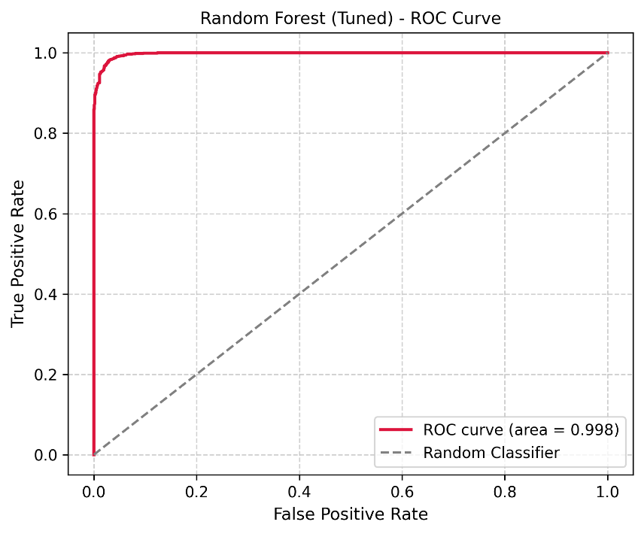
Figure 2: Random Forest (Tuned) ROC Curve
Compared to the baseline Random Forest, which already performed very well (F1-score = 0.977, ROC-AUC = 0.998, with 1,212 phishing and 942 legitimate URLs correctly classified), the tuned model provided a slight improvement in F1-score (0.978) while maintaining the same ROC-AUC (0.998). This indicates that while the model’s ability to rank phishing versus legitimate URLs across all thresholds was already near-optimal, hyperparameter tuning refined the decision boundary at the default threshold, resulting in a modest increase in correctly classified instances. Such improvements, though incremental in metrics, are practically meaningful in security-sensitive contexts where even a few misclassifications can have significant consequences. For the SVM, hyperparameter tuning led to a clear improvement over the baseline, achieving an F1-score of 0.970 and ROC-AUC of 0.994, correctly classifying 1,204 phishing and 932 legitimate URLs (Figure 3). Compared to the baseline SVM (F1 = 0.955, ROC-AUC = 0.990), the increase in F1-score represents a moderate improvement in threshold-dependent performance, while the ROC-AUC improvement, though modest, indicates enhanced ability to distinguish phishing from legitimate URLs across all thresholds. These findings demonstrate that hyperparameter tuning successfully refined the SVM’s decision boundary, improving predictive reliability and reducing misclassifications, thereby making the tuned SVM more competitive with ensemble-based models.
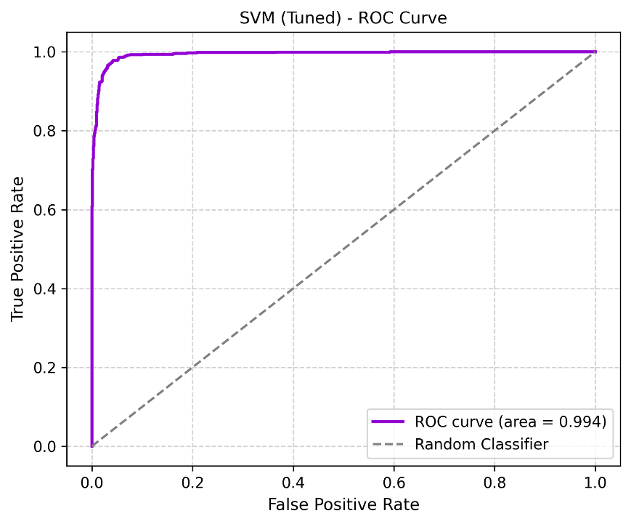
Figure 3: SVM (Tuned) ROC Curve
Hyperparameter tuning effectively refined the decision boundaries of both the Random Forest and SVM models, improving threshold-dependent metrics such as Accuracy, Precision, Recall, and F1-score. The Random Forest, in particular, achieved near-perfect discrimination (ROC-AUC ≈ 0.998), while both tuned models maintained recall above 0.97, which is critical in phishing detection where minimizing false negatives is essential. By reducing misclassifications and enhancing predictive reliability, tuning made both models more robust and better suited for detecting phishing URLs in security-critical contexts. The ROC curves further illustrate the reduction in misclassified samples, confirming that careful hyperparameter optimization can meaningfully improve model performance without introducing overfitting, even when baseline models already exhibit strong classification ability.

Feature Importance Analysis
Not all URL-based features contribute equally to the performance of phishing detection models. Identifying the most influential features is therefore essential for understanding how the model makes predictions and improving interpretability. Prior studies have shown that analyzing feature importance provides valuable insights into which features drive model decisions, thereby helping to interpret results and build trust in the model’s behavior. Accordingly, a feature importance analysis was conducted on the tuned Random Forest classifier to identify which URL-based features have the greatest impact on phishing detection outcomes. The model provides a relative importance score for each feature based on its contribution to classification performance. The top ten most influential features indicate that SSLfinal_State (0.313) and URL_of_Anchor (0.263) dominate the feature space, together accounting for more than 57% of the model’s predictive power. These two attributes are followed by web_traffic (0.071), having_Sub_Domain (0.065), and Links_in_tags (0.043). Other features such as Prefix_Suffix, SFH, Links_pointing_to_page, Request_URL, and Domain_registeration_length contributed less substantially but still provide complementary predictive signals.

4.2 Discussion
The experimental evaluation of the five supervised machine learning classifiers demonstrates their effectiveness in detecting phishing websites using URL-based features. All models achieved strong predictive performance, with Accuracy ranging from 0.929 to 0.976 and F1-scores between 0.937 and 0.978 on the hold-out test set. These findings are consistent with prior research in cybersecurity, which highlights the reliability of ensemble methods and kernel-based classifiers for phishing detection tasks Logistic Regression served as a robust linear baseline, producing an F1-score of 0.937 and a Recall of 0.950. Its high recall confirms its strength in identifying phishing websites, an essential requirement in cybersecurity where missed detections can lead to severe breaches. However, slightly lower precision compared to ensemble methods resulted in a moderate rate of false positives. Decision Tree outperformed the linear baseline with an F1-score of 0.974 and ROC-AUC of 0.980, benefiting from its ability to capture non-linear feature interactions. Similarly, KNN achieved strong performance (F1-score 0.954, ROC-AUC 0.986), showing that proximity-based methods can effectively discriminate between phishing and legitimate URLs. Nonetheless, KNN’s reliance on storing and comparing all training samples limits scalability in real-time deployments. Hyperparameter optimization enhanced the performance of Random Forest and SVM. Random Forest (tuned with n_estimators = 100, max_depth = 20, min_samples_split = 2, min_samples_leaf = 1) achieved the best overall results, with an F1-score of 0.978 and ROC-AUC of 0.998. Its ROC curve further confirmed its superior capability in minimizing misclassifications. SVM (tuned with C = 10, gamma = ‘scale’, kernel = ‘rbf’) also demonstrated marked improvement, achieving an F1-score of 0.970 and ROC-AUC of 0.994. While slightly below Random Forest in predictive performance, SVM remains a strong non-ensemble alternative, particularly for capturing complex, non-linear decision boundaries.
The feature importance results provide meaningful insights into the behavioral characteristics of phishing websites. The prominence of SSLfinal_State suggests that attackers often neglect proper SSL/TLS certification or use invalid certificates, making SSL-related indicators a strong discriminator between benign and malicious sites. Similarly, the high importance of URL_of_Anchor reflects the common phishing strategy of embedding misleading, irrelevant, or empty hyperlinks within web pages to deceive users. The role of web_traffic as the third most important feature aligns with prior findings that phishing sites typically attract minimal or suspiciously irregular visitor traffic compared to legitimate domains. Likewise, having_Sub_Domain emerged as a critical attribute, reinforcing the observation that phishing websites frequently exploit excessive subdomain structures to obscure malicious intent. Although features such as Request_URL, Domain_registeration_length, and Links_pointing_to_page exhibited lower individual contributions, they are not redundant. Instead, these attributes enhance the robustness of detection when combined with stronger indicators, demonstrating the complementary nature of URL-based features. Taken together, these findings underscore the importance of combining structural features such as subdomains and prefix-suffix usage, content-level indicators including anchor links and request URLs, and security-related attributes such as SSL certificates and web traffic for effective phishing detection. The analysis further supports the view that no single feature is sufficient in isolation, but rather a weighted combination provides robust detection capability.

Comparative Insights
The results highlight the superiority of ensemble methods, particularly Random Forest, in balancing precision and recall, making them highly suitable for phishing detection systems where both minimizing false positives and maximizing detection rates are critical. Kernel-based methods like SVM provide competitive performance and are attractive when computational efficiency or interpretability of feature transformations is desired. Linear models such as Logistic Regression remain valuable for their simplicity and interpretability, while Decision Trees offer a balance between accuracy and explainability. KNN, although effective, is less practical for large-scale or real-time applications due to its instance-based computation. Importantly, all models achieved ROC-AUC values above 0.926, confirming that URL-based features contain highly discriminative information for phishing detection.

Practical Implications
From an operational perspective, Random Forest (Tuned) is recommended for deployment in cybersecurity systems where high detection accuracy and robustness are priorities. SVM (Tuned) offers a competitive alternative in environments where model compactness or interpretability of decision boundaries is critical. Logistic Regression serves as a lightweight, interpretable baseline suitable for integration into hybrid detection systems, particularly for preliminary filtering before deploying more computationally intensive models. Decision Trees provide interpretable decision paths, while KNN, despite strong performance, is better suited for smaller-scale applications due to scalability constraints. Overall, these findings reinforce that combining robust feature engineering with appropriate model selection and hyperparameter tuning yields highly effective phishing detection systems. Ensemble methods, particularly Random Forest, offer the strongest balance of detection accuracy and reliability, while alternative models remain valuable under different deployment constraints.

Limitations and Future Work
Although the present study demonstrates strong classification performance, several limitations should be acknowledged. First, the evaluation was restricted to URL-based features; integrating additional contextual and behavioral attributes such as website content or domain registration data may further enhance detection accuracy. Second, instance-based models like KNN may face scalability challenges when applied to very large datasets. Finally, hyperparameter tuning was limited to Random Forest and SVM; future work could employ automated optimization techniques (e.g., Bayesian optimization) or investigate deep learning methods capable of capturing more complex feature representations

V. Conclusion

The findings of this study demonstrate that well-tuned ensemble and kernel-based models can reliably detect phishing websites, achieving high F1-scores and ROC-AUC values. Among the classifiers, Random Forest with hyperparameter tuning provided the best balance between precision and recall, establishing itself as the most effective model for URL-based phishing detection. SVM also performed competitively, offering a strong alternative to ensemble methods. URL-based features proved highly effective for phishing classification, and hyperparameter tuning enhanced predictive performance. While Random Forest emerged as the top-performing model, Logistic Regression, Decision Tree, and KNN remain valuable depending on trade-offs between interpretability, computational efficiency, and deployment requirements. Ensemble approaches, particularly Random Forest, outperformed single-model methods, delivering superior recall and F1-scores, which is especially important in cybersecurity where minimizing false negatives is critical to preventing breaches. Visual analyses of confusion matrices and ROC curves confirmed the robustness and reliability of the classifiers. These results provide a strong foundation for applying machine learning to practical cybersecurity defenses.

Biographies

[1] A. Das, S. Baki, A. El Aassal, R. Verma, and A. Dunbar, “SoK: A Comprehensive Reexamination of Phishing Research From the Security Perspective,” IEEE Commun. Surv. Tutorials, vol. 22, no. 1, pp. 671–708, 2020, doi: 10.1109/COMST.2019.2957750.
[2] D. Pienta, J. B. Thatcher, and A. Johnston, “Protecting a whale in a sea of phish,” Journal of Information Technology, vol. 35, no. 3, pp. 214–231, 2020, doi: 10.1177/0268396220918594.
[3] A. Y. Fu, L. Wenyin, and X. Deng, “Detecting Phishing Web Pages with Visual Similarity Assessment Based on Earth Mover’s Distance (EMD),” IEEE Trans. Dependable and Secure Comput., vol. 3, no. 4, pp. 301–311, Oct. 2006, doi: 10.1109/tdsc.2006.50.
[4] S. Gastellier-Prevost and M. Laurent, “Defeating pharming attacks at the client-side,” in 2011 5th International Conference on Network and System Security, Milan, Italy: IEEE, Sep. 2011, pp. 33–40. doi: 10.1109/ICNSS.2011.6059957.
[5] N. F. Almujahid, M. A. Haq, and M. Alshehri, “Comparative evaluation of machine learning algorithms for phishing site detection,” PeerJ Computer Science, vol. 10, p. e2131, Jun. 2024, doi: 10.7717/peerj-cs.2131.
[6] R. Mrm, N. F.A.M, S. A.M, and S. K.A.S, “A Comparative Analysis of Machine Learning Models for URL-Based Phishing Detection,” Apr. 15, 2025, Springer Science and Business Media LLC. doi: 10.21203/rs.3.rs-6439154/v1.
[7] T. Wood, V. Basto-Fernandes, E. Boiten, and I. Yevseyeva, “Systematic Literature Review: Anti-Phishing Defences and Their Application to Before-the-click Phishing Email Detection”.
[8] S. Kavya and D. Sumathi, “Staying ahead of phishers: a review of recent advances and emerging methodologies in phishing detection,” Artif Intell Rev, vol. 58, no. 2, Dec. 2024, doi: 10.1007/s10462-024-11055-z.
[9] J. Li, “Area under the ROC Curve has the most consistent evaluation for binary classification,” PLoS ONE, vol. 19, no. 12, p. e0316019, Dec. 2024, doi: 10.1371/journal.pone.0316019.
[10] V. Vajrobol, B. B. Gupta, and A. Gaurav, “Mutual information based logistic regression for phishing URL detection,” Cyber Security and Applications, vol. 2, p. 100044, 2024, doi: 10.1016/j.csa.2024.100044.
[11] D. S. Ahmed, “Phishing Websites Detection Model based on Decision Tree Algorithm and Best Feature Selection Method,” Turkish Journal of Computer and Mathematics Education (TURCOMAT), vol. 13, no. 1, pp. 100–107, Jan. 2022, doi: doi.org/10.17762/turcomat.v13i1.11964.
[12] M. Sannigrahi and R. Thandeeswaran, “Predictive Analysis of Network-Based Attacks by Hybrid Machine Learning Algorithms Utilizing Bayesian Optimization, Logistic Regression, and Random Forest Algorithm,” IEEE Access, vol. 12, pp. 142721–142732, 2024, doi: 10.1109/ACCESS.2024.3464866.
[13] W. Xing and Y. Bei, “Medical Health Big Data Classification Based on KNN Classification Algorithm,” IEEE Access, vol. 8, pp. 28808–28819, 2020, doi: 10.1109/ACCESS.2019.2955754.
[14] R. Mohammad and L. McCluskey, “Phishing Websites.” UCI Machine Learning Repository, 2012. [Online]. Available: [Online]. Available: https://doi.org/10.24432/C51W2X
[15] A. Géron, Hands-On Machine Learning with Scikit-Learn, Keras, and TensorFlow: Concepts, Tools, and Techniques to Build Intelligent Systems, 2nd Edition. O’Reilly Media, Inc., 2019.

